|  |
| --- |
|  |
|  |

|  |  |  |  |  |  |
| --- | --- | --- | --- | --- | --- |
| REVISION HISTORY | | | | | |
| Ver. | Description of Change | Author | Date | Approved | |
| Name | Effective Date |
| 1.0 | Initial status | Olga Hilko | 21-NOV-2017 |  |  |

Contents

1. Dim load and insert 3

2. Fact generation 3

3. Advanced Grouping tasks – Reports 3

3.1. Create Test AdHoc SQL - Year Report (CUBE) 3

3.2. Create Test AdHoc SQL – ROLLUP by Time 4

# Dim load and insert

All scripts are on git.

All work was hand on BL_CL and BL_3NF layers. DDL Scripts for both layers were prepared.

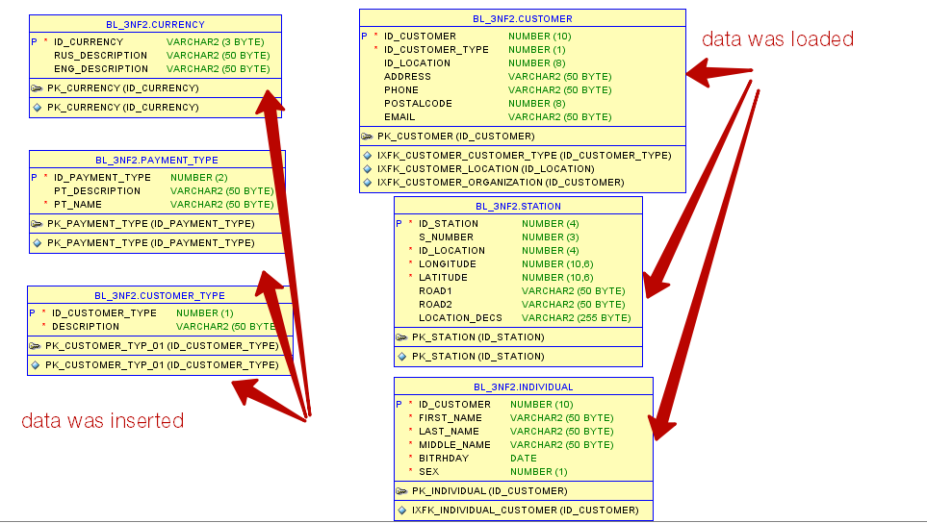

# Fact generation

Foreign keys for fact Payment were generated from the Dimentions.

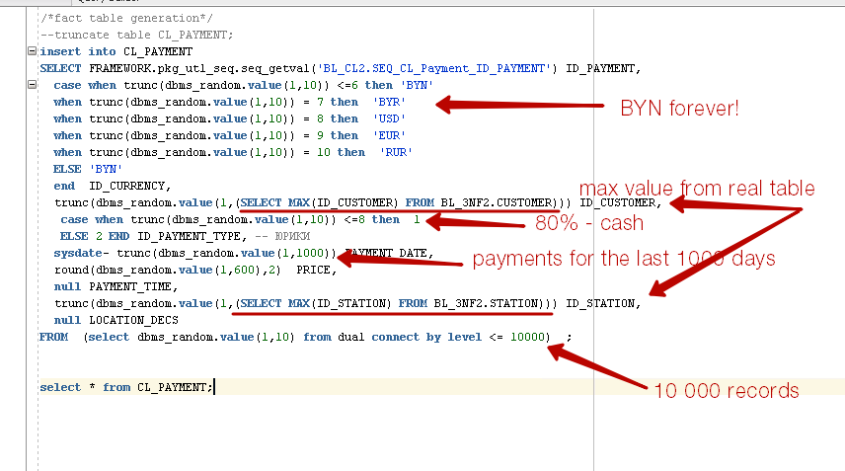

# Advanced Grouping tasks – Reports

## Create Test AdHoc SQL - Year Report (CUBE)

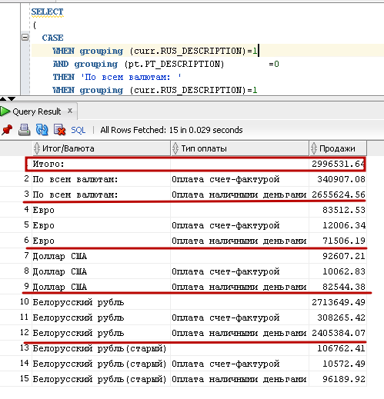

## Create Test AdHoc SQL – ROLLUP by Time

